**Gated Recurrent Unit (GRU) Networks**

**Overview**

GRUs are a type of Recurrent Neural Network (RNN) designed to efficiently capture dependencies in sequential data, such as time series, text, or speech. GRUs help solve the vanishing gradient problem found in traditional RNNs by using gating mechanisms to control information flow.

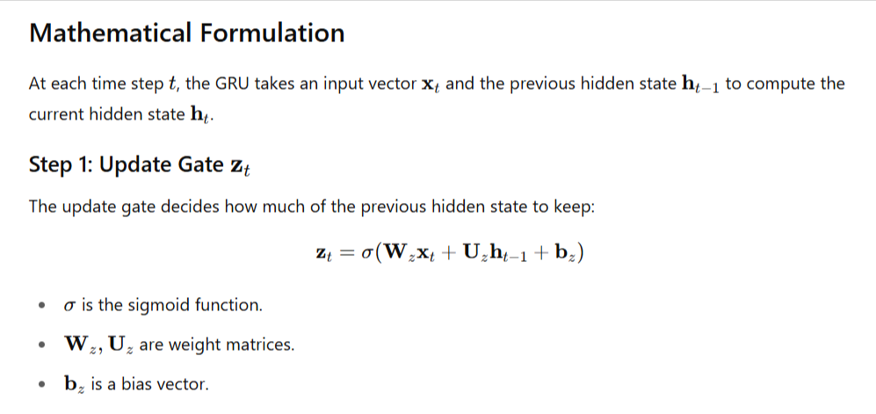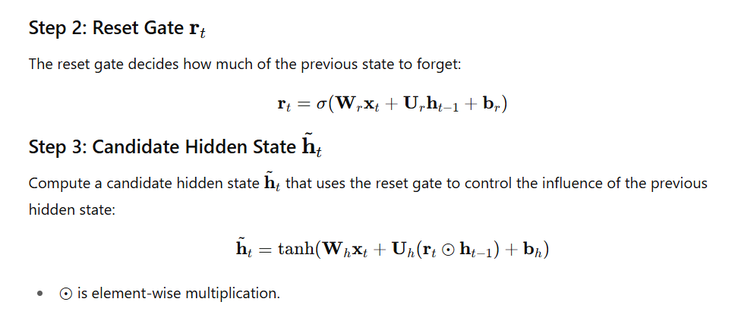



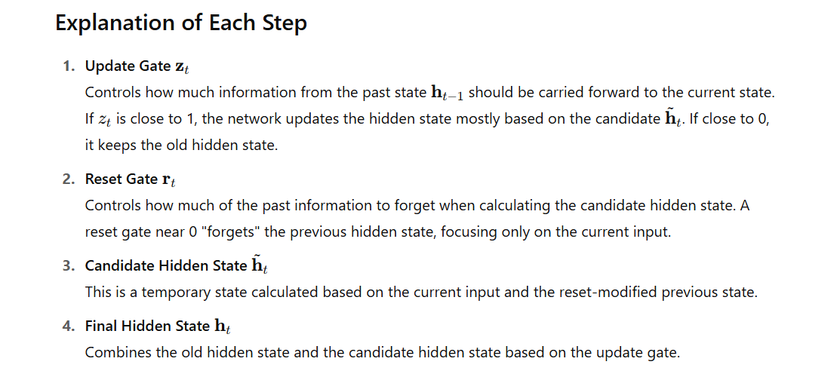

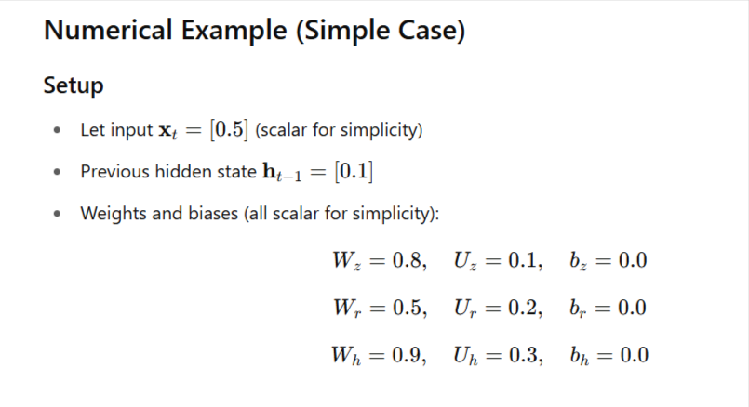

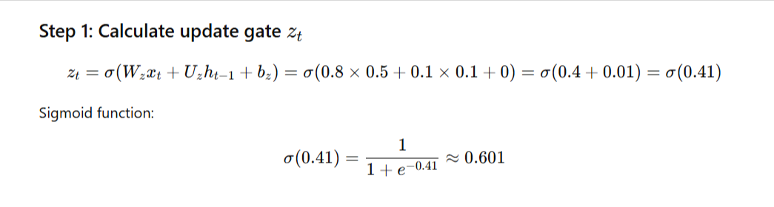

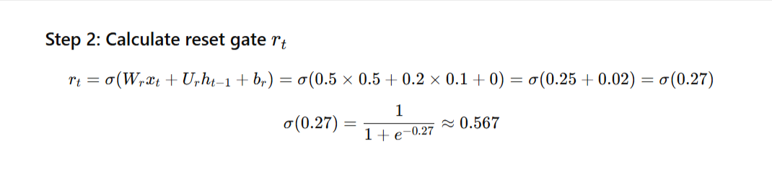

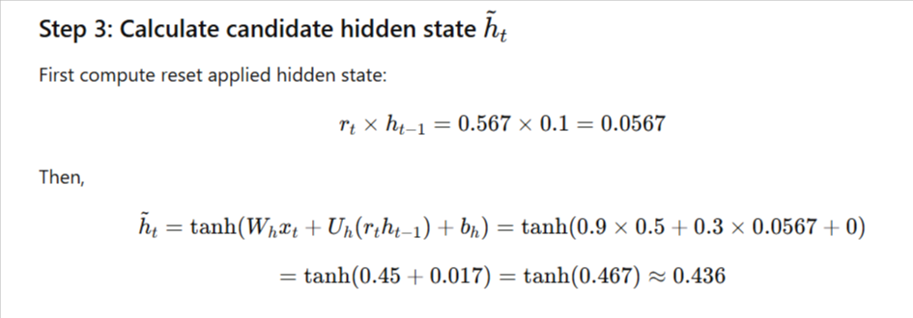

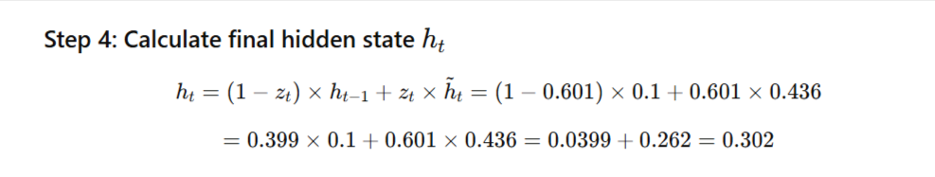

|  |  |
| --- | --- |
| **Variable** | **Value** |
| Zt (update gate) | 0.601 |
| Rt (reset gate) | 0.567 |
| h~t (candidate hidden) | 0.436 |
| Ht (new hidden state) | 0.302 |